Proyecto “Cuando Yo Era Niñ@”

Fecha de Entregar: ___________

Objectivo: This project is going to focus on the usage of the Preterite vs. the Imperfecto. The Project will be in the PAST TENSE, BE SURE TO USE THE APPROPRIATE CONJUGATIONS.

Requerimientos:
- Each Student will create an on-line poster using www.edu.glogster.com, or www.prezi.com (or those without internet will make a physical poster).
- Each Student will post 10 pictures of activities he/she used to do when they were young (Cuando Yo era niño…)
- To accompany each picture, the student will write 2 Sentences.
  - The First of which tells what they used to do…(imperfect tense)
  - The Second of which tells what happened “One time…” (preterit)
- Reflections: I want you to analyze your own work, compare and contrast the different usages of the Past Tense. (Half Page, English)

Ejemplo: Cuando yo era niño yo siempre salía a jugar con mis amigos en la playa. Una vez, me taparon con mucha arena.

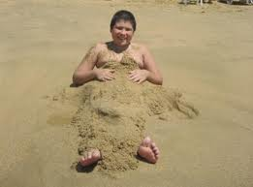

Puntaje:
- Cada ilustración con comentario= 7 puntos (10 X 7 = 70)
- Presentación en Clase= 20 puntos
- Reflección y Auto-Calificación: 10 puntos

* Cada error = 1 punto

